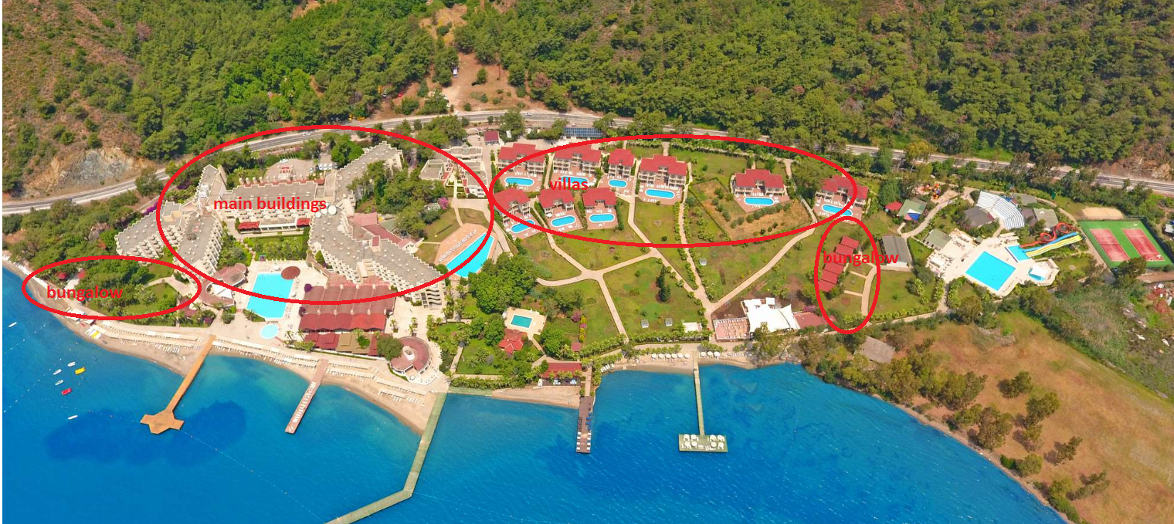
Main buildings: Main Building Land View, Main Building Sea View, Family Room Land View, Family Room Sea View.
Villas: Deluxe Room.
Bungalow: Deluxe Superior Jacuzzi.

