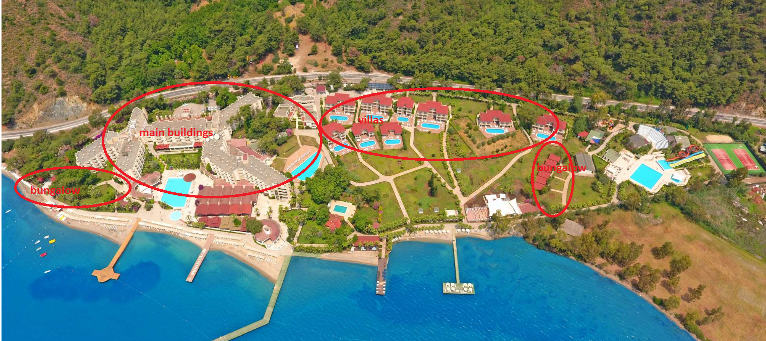
Main buildings: Standard Land View, Standard Sea View, Family Room Land View, Family Room Sea View.
Villas: Deluxe Room.
Bungalow: Superior Jacuzzi.

