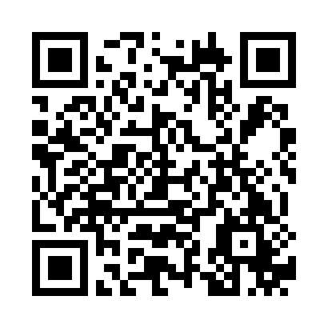
Kindly scan the below QR code for in stay survey

Restaurants& Bars
Four Corners Restaurant
Breakfast set menu 07h30 – 10h00
Dinner set menu 18h30 –21h00
Beach & Pool Bars
La Perla- Pool bar 10h00 – 19h00
Late Breakfast 10h30 – 12h00
Lunch ala carte menu 12:30h00 – 15 h00
Ice cream 12h00 – 17h00

Paradisio – Beach Snack bar 10h00 – 18h00
Lunch ala carte menu 12:30h00 – 15 h00
Beach kiosk 1 beach kiosk
Beverage 10:00 -17:00
Food snacks 12:00-16:00

Lobby Bars
Fayrouz -Lobby Bar 10h00 – 24h00

à la carte restaurants (19h00 – 21h30). Smart Causal
Nino’s– Italian cuisine
Sofra– Middle Eastern Cuisine

Subject to extra charge depending on your All Inclusive formula. Previous booking is required by the self-reservation screens at Aquamarine lobby area.

Activities
Free of charge  - Tea & coffee facilities refreshed daily, complimentary  - Wake up calls  - Exchange & ATM machines  - Towel (free towels and sun beds)  - Daily soft animation  - Live music on open terrace every other day at the evening  - Aerobic/Gym  - Fitness Centre opens 07h30–19h30  - Table Tennis | - swimming pools, partly heated from 01.11. to 31.03. in Aquamarine.  - Aqua parks slides opened daily from 10h00 to 13h00 & 14h30 – 17h00), suitable for children over 10 years or taller than 120cm. (aqua parks on the beach working 2 days alternatively)  - Tennis court (floodlit against extra charge)  - Jogging track 1400 meters (start point behind the SPA Center)
Paid  - Mini-bar beverages and snacks  - Imported alcoholic drinks  - Doctor (clinic) 09:00 Till 21:00. Doctor Services 24 Hours  - Pharmacy. 24 Hours  - Laundry/ Dry Cleaning Service | - Shops  - Beach Lodge.  - Late check-out, please check the availability one day in advance with the front desk with extra charge
Important to know
- Breakfast & Lunch boxes: Breakfast & lunch boxes are to be ordered one day in advance before 20h00hrs at the Reception.
- Beverages: Our All-inclusive formula is from 10h00to 00h00, Soft drinks are served in glasses and not bottled, as well as all local cocktails are inclusive. Imported alcoholic drinks are with extra charge.
- Safe Box: Free of charge, for your valuables as the hotel is not responsible for any loss of valuables or belongings out of the safe. Please leave your safe box open before departure.
- Internet Connection: Free internet speed 01 MB with 2 devices per room. For more speed internet of 05 MB is subject to extra charge: Jaz 100 (3 GB 100 EGP); Jaz 150 (5 GB 150 EGP); Jaz 300 (8 GB 300 EGP); Jaz 550 (15 GB 550 EGP) –For Wi-Fi after check out, please contact front desk to get the code.
- Beach Use: Sea shoes are recommended. Very shallow water.
- The reservation of sun beds is not allowed. The hotel reserves the right to remove and store any towels and personal belongings left unattended for more than 1 hour
(to be kept by Lost & Found office).
- Dress Code: Smart casual is recommended; shorts and flip flops are not allowed in the evening in all the Restaurants and Lobby area.
- Check-Out: at 12:00 noon time, please return your key card during the check out and leave the beach/pool towel in the room before check, in case of missing or lost to pay 10$.
- Food Allergy: available at your request, please refer back to the restaurant manager and kitchen chef.
- Items you can borrow upon your request: adaptor, iron, toilet seat for kids and anti-slippery mat for kids, wheel chairs, baby trolley lock, prayer mat & Holy Quran.
- Items you can rent: Baby trolley – 15 Euro per week.
- No outside guests will be allowed to visits the guests during their stay.
- There must be a 2-meter distance between each sunbed.
- Housekeeping will not be cleaning/changing bedding on a daily basis, and guest must keep their rooms clean.
- Table service in restaurant, bars and public areas there must be a 1- meter distance between each person.
- Maximum of 6 persons only seated at the table in restaurant.
- There will be no health club, Jacuzzi, sauna or steam room available during the guest stay.
- There will be no buffet menu available in the restaurants, only set menus for the guest during their stay.
- Please hang make up my room sign if you wish your room to be cleaned as the room will be not automatically cleaned by our staff.
- No room service available & kids club

For any maintenance or housekeeping request, please refer to our Guest Service Center – dial 0 or 4

