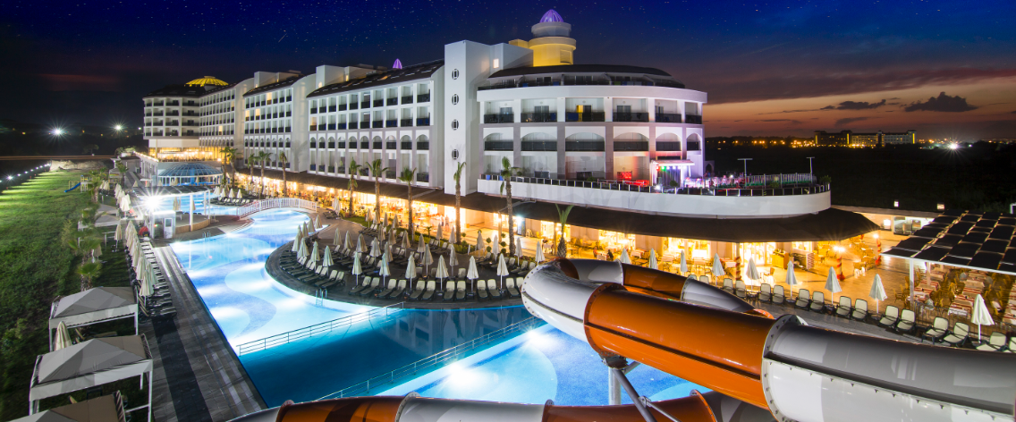

**FACTSHEET 2025-26 WİNTER AI+**

**Category** : 5*-Hotel

**Address**  : Titreyengöl-Side- Antalya

**Telefon no** : 0(242) 744 15 50

**Fax no** : 0(242) 744 15 70

**E-Mail** :info@lrshotels.com

**Website** : www.lrshotels.com

**Opening** : 2015

**Area** : 13.000 m2

**Capacity** : 406 Rooms, 836 Beds

**Languages** : Turkish, English, German, Russian

**Location** : 250 meters to the beach (private hiking trail)

: To Side 7 km, to Antalya 70 km,

To Manavgat 5 km, to Antalya Airport 65 km.

**Transport** : Taksi, Minibus (Dolmuş)

**Credit Cards**  : Visa,Master Card

**The Room Types** : 392 Standard Rooms (partial side sea & sea view & landview & river),

11 Family Rooms,

3 handicapped accessible rooms

**Standard Double Room L.View** : 362 rooms – 16-25 m2 Min. 1 - Max. 3 people

Stylish rooms with minibar (beers, soft drinks, Cola, Fanta, water)

Satellite LCD TV, WiFi (free), radio, direct dial telephone,

Split air conditioning, safe (free), laminate flooring,

Balcony, shower & toilet in the bathroom, cosmetic mirror, hairdryer.

Double bed (French bed). + A single bed

**Standard double room with partial sea view: 10 rooms – 16–25 m², min. 1–max.3persons**

Minibar (beers, soft drinks, Cola, Fanta, water)   
 Satellite LCD TV, WiFi (free), radio, direct dial telephone,  
 Split air conditioning, safe (free), laminate flooring,   
 Balcony, shower & toilet in the bathroom, cosmetic mirror, hairdryer.

Double bed (French bed). + A single bed

**Standard double room with sea view: 10 rooms – 16–25 m², min. 1–max. 3 persons :**

Minibar (beers, soft drinks, Cola, Fanta, water)   
 Satellite LCD TV, WiFi (free), radio, direct dial telephone,  
 Split air conditioning, safe (free), laminate flooring,  
 Balcony, shower & toilet in the bathroom, cosmetic mirror, hairdryer.

Double bed (French bed). + A single bed

**Disabled accessible rooms: 3 rooms - 27 m2 - Min 1 - Max 2 pax**

Minibar (beers, soft drinks, Cola, Fanta, water)

Satellite LCD TV, WiFi (free), radio, direct dial telephone,

Split air conditioning, safe (free), laminate flooring,

Balcony, shower & toilet in the bathroom, cosmetic mirror, hairdryer.

Double bed (French bed). + A single bed

**Family Room :11 Rooms – 45 m2 - Min 2 - Max 4 pax**

Minibar (beers, soft drinks, Cola, Fanta, water)   
 Satellite LCD TV, WiFi (free), radio, direct dial telephone,

Split air conditioning, safe (free), laminate flooring,

Balcony, shower & toilet in the bathroom, cosmetic mirror, hairdryer.

With two bedroom (there is) A double (french) bed in one of the room and twin

beds other.

**Accommodation** **: All Inclusive Plus.**

**Import and local drinks are served 10.00-24.00 in lobby bar(after**

**According to the program**

|  |  |  |  |
| --- | --- | --- | --- |
| Breakfast | (open buffet) | 07.00 – 10.00 | Main Restaurant |
| Late breakfast | (open buffet) | 10.00 – 10.30 | Main Restaurant |
| Lunch | (open buffet) | 12.30 – 14.30 | Main Restaurant |
| Patisserie |  | 10.00 - 17.00 | Snack-Restaurant |
| Dinner | (open buffet) | 18.30 -20.30 | Main Restaurant |
| Night Soup |  | 23.30 -24.00 | Snack-Restaurant |

Snack Bar **10:00-24:00** **in Snack Bar**

**İce Cream 14.00-16.00 in Snack Restorant**

**Bars**

Lobby Bar 10.00-24.00 (Free) International import of alcoholic and non-alcoholic soft drinks

Disco Bar 22.00-24.00 (Free) International import of alcoholic and non-alcoholic soft drinks

Snack rest.&Bar 10:00-24:00(Free) Local alcoholic and non-alcoholic soft drinks

**Sport**

Fitness Center (Free)

Table tennis (Free)  
Arrow (Free)

**Pools**

1 heated indoor swimming pool 85 m2

1 heated children's pool 15 m2

**ShoppingCenter**Market, Hair Salon, Jewelry, Gift Shop, Boutique, Silver Shop, Shoe Shop, Wallet Shop, Photos Shop.

Shopping Center (Extra Charge)

**Spa & Wellnes**

Turkish Bath (Free)

Steam Room (Free)

Sauna (Free)

Massage, Wellnesscenter (Extra Charge)  
Peeling (Extra Charge)

**Healthcare**

Healthcare (Extra Charge)

**Other**

Safe (in room) (Free)

Bath Towel (Free)   
Sunbed (Free)

Sonnenschirm (Free)

TV room (satellite) (Free)

Telephone, Fax, Photocopy (Extra Charge)

Baby Bed (Free)

Laundry Service (Extra Charge)

Internet (wireless in the lobby) (Free)

Internet (in the room) (Free)

Room service (Extra Charge)  
Orange juice (breakfast) (Extra Charge)

Drink Bottle (Extra Charge)

**Animation**

Soft Animation (Free)

Live Music(Some Evenings ) (Free)

Disco (Free)

Billiards (Free)

**For Children**

Children’s Buffet (Free)

High Chair (Free)

Mini Club (Free) (04-12 years) (10.00-12.00/15.00-17.00)

İn Door Children’s Pool (Free)   
Baby Sitter (Extra Charge)

Baby Buggy (Free) (Reservation)

(The beach is open in summer, in winter period: there is no shuttle, food or beverage service in winter. Changes may be made by the management depending on weather conditions at the end of the season and at the beginning of the season.)

**Electricity: 220 V *Pets not allowed.**

**\*\*Depending on conditions, service times are subject to change.**