# “ALL INCLUSIVE” PROGRAMME SUMMER SEASON 2020

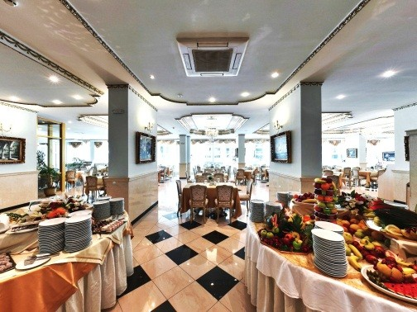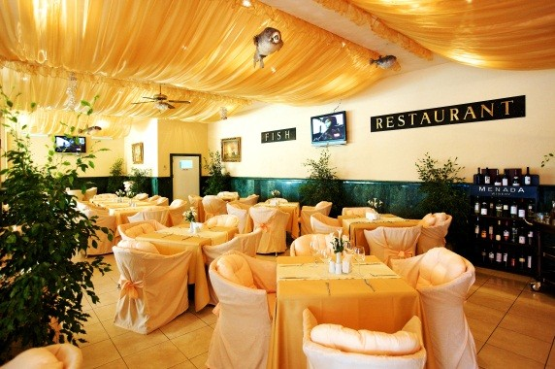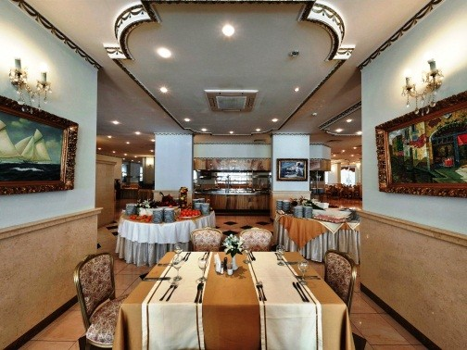

## DINING

|  |  |
| --- | --- |
| **BREAKFAST 07:30 – 10:00**  Main Restaurant | Freshly baked pastry and croissants, prepared at the moment omelets, eggs and pancakes, a selection of hot and cold sausages and cheeses,  healthy food buffet, fresh fruits. |
| **LUNCH 12:00 – 14:00**  Main Restaurant | Buffet with fresh salads, hot and cold soups, a variety of hot dishes, Show-cooking, baby and children food court,  freshly baked bread, dessert bar, seasonal fruits. |
| **AFTERNOON BREAKFAST 14:30 – 17:00**  Snacks Restaurant | Freshly prepared pizza, club sandwiches, warm appetizers and pastries. |
| **DINNER 18:00 – 21:00**  Main Restaurant | Rich variety of salads, starters, hot meals, show-cooking, barbeque, Italian buffet, children's buffet, healthy food court,  selected desserts, fresh fruits. Three times per week a theme buffet. |

**Main Restaurant:**

Air-conditioned hall for non-smokers.

The smoking area is on the terrace of the restaurant. Dress code “smart casual” required at dinner.

**BEVERAGES**

|  |  |
| --- | --- |
| **10:00 – 23:00** |  |
| * **POOL BAR** | Soft drinks, beer, local alcoholic beverages, white, rosé and red wine, |
| * **SNACKS BAR** | non-alcohol and alcohol cocktails, |
| * **RESTAURANT BAR** | warm beverages (tea, coffee, milk, cappuccino, cacao) |
| * **SKY BAR** |  |

|  |  |
| --- | --- |
| **Services included in All Inclusive Program:** | **Additional charge:** |
| * AQUAPARK for adults and children * Children playground * Complimentary sunbeds and umbrellas on the swimming pools * Sauna * Fitness * WiFi in the Lobby and Swimming pool area * WiFi in the rooms * Safety Deposit Box in room * Animation program (01.06.2020 – 15.09.2020) in English, Russian, German and Bulgarian, including: * Children’s club (4-12 years old), Children’s disco, Thematic daytime games * Sport activities: Pool Volleyball, Zumba, Aerobics, Stretching, Water Gymnastics, Table Tennis, Chess, Cards * Evening Entertainment Shows in Animation Hall | * SPA treatments * Parking * Imported alcoholic drinks at Lobby bar * Billiard, Computer games, Darts * Laundry service |

**PLANETA HOTEL & AQUA PARK**

**(Part of All Inclusive Programme for Summer Season 2020)**

