

Hotel Fact Sheet

Winter 2019 / 2020

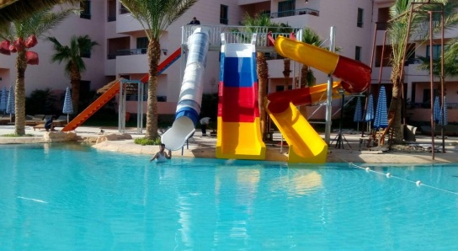 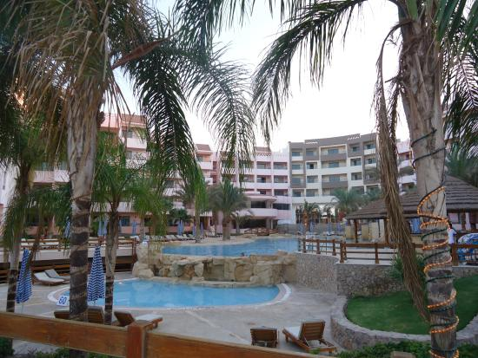 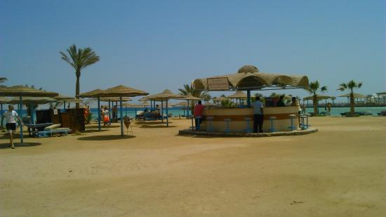



Location

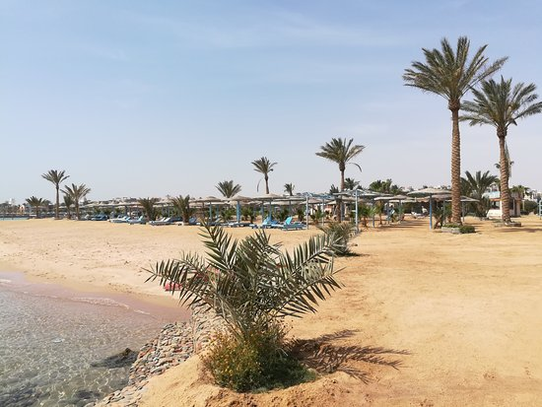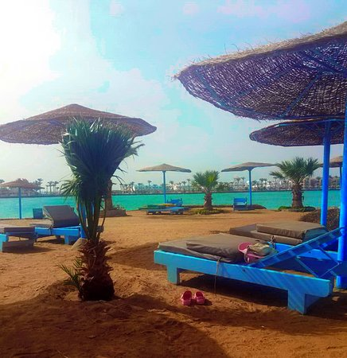

|  |
| --- |
| Zahabia Hotel & Beach Resort Hurghada is a luxury 3 stars hotel with a very privileged location of Hurghada.  About 2 KM to downtown & 7KM to Hurghada international airport. Located on the Red Sea, with a sandy beach, in a very quiet place for relaxing. Combining an exquisite blend of architecture and refined services.  Zahabia Hotel & Beach Resort will be perfect place for an unforgettable holiday. |

|  |  |  |  |  |
| --- | --- | --- | --- | --- |
| Hotel Name | Zahabia Hotel & Beach Resort |  | Check In Time | 14.00 |
| Category | 3*  4* |  | Check Out Time | 12.00 Noon |
| Postal Address | Cornish Road, Hurghada, Red Sea |  | Beach Location | 2nd Line |
| Opening Date | 1996 |  | No of Buildings | 15 |
| Renovation Date | 2018 |  | Floors | 2 - 4 & 5 |
| Total Area | 82.000 M2 |  | Standard Double Rooms | 169 |
| Beach Length | 434 M |  | Standard Triple Rooms | 2 |
| AirPort | 7 KM |  | A1 Bedroom apartment | 95 |
| City Center | 2 KM |  | One Bedroom: Large Bedroom, living room &small American equipped kitchen | |
| Transport | Taxi Service - Mini Bus |  |
| Nearest Mall | Carrefour |  | A2 Bedroom apartment | 47 |
| Telephone | +2 065 / 3615039 - 3615852 |  | Two Bedrooms: Large Bedroom, twin bedroom, living room & small American equipped kitchen | |
| Call Center | +2 01200476666 |  |
| Website | [www.zahabiaresort.com](http://www.palmbeachhostmark.com) |  | A1 Villas | 3 |
| E-Mail | [zahabia_resort@yahoo.com](mailto:info@palmbeachhostmark.com)  reservation@zahabiaresort.com |  | one Bedrooms large living room, 2bathrooms, equipped kitchen & terrace with garden | |
| Facebook | Zahabia Beach Resort |  | A2 Villas | 17 |
| Service Languages | English, German, Russian, Arabic and French |  | Two Bedrooms, large living room, 2bathrooms, equipped kitchen & terrace with garden | |
| Meals Plan | BB - HB - FB - All Inclusive |  | Standard Room in Villas | 20 |
| Internet / Wi-Fi | Free Normal speed connection |  | Total Rooms | 417 |
| Accepted Currencies | EGP, Euro, USD |  | Total Units | 353 |
| Credit Cards | Master Card, Visa |  | Pets | Not allowed |



Type Of Rooms 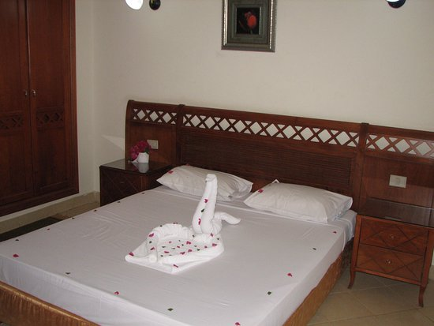 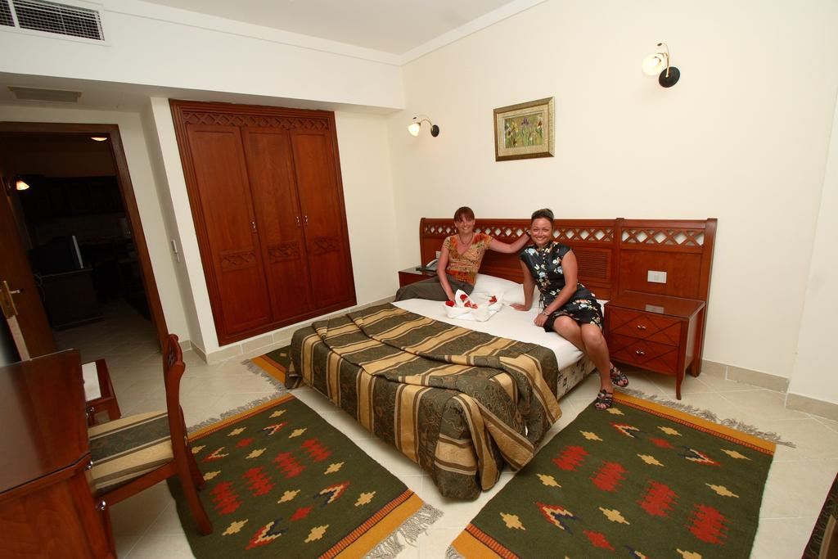

|  |  |  |  |  |  |  |  |  |  |
| --- | --- | --- | --- | --- | --- | --- | --- | --- | --- |
| Type | Standard  Twin | Standard  Large bed | Standard  Triple | A1  Apartment  King  Bedroom | A1  Apartment Twin  Bedroom | A2  Apartment  1 King bedroom  1 Twin bedroom | Villa  Standard  King Bed | A1 Villa  1 Twin bedroom | A2 Villa  1 King bedroom 1 Twin bedroom |
| Number of Rooms | 100 | 69 | 2 | 76 | 19 | 47 | 20 | 3 | 17 |
| Sofa Bed | No | 8 | No | 76 | 19 | 47 | No | No | No |
| Sitting Room | No | No | No | Yes | Yes | Yes | No | Yes | Yes |
| Equipped Kitchen | No | 4 Rooms Only | No | Yes | Yes | Yes | No | Yes | Yes |
| Max Capacity | 2 | 2 | 3 | 2+2CH /3 AD | 2+2ch /  3 AD | 4AD + 2 Ch /  5 AD | 2 | 3+1CH /4 AD | 4AD + 2 Ch /  5 AD |
| M2 | 27 -34 M2 | 27 -34 M2 | 41 - 52 M2 | 45 - 57 M2 | 45 - 57 M2 | 65 - 74 M2 | 25 -35 M2 | 65 - 74 M2 | 85 - 95 M2 |
| Terrace / Balcony | Yes | Yes | Yes | Yes | Yes | Yes | Yes | Yes | Yes |
| Shower Cabin | Yes | Yes | Yes | Yes | Yes | Yes | Yes | Yes | Yes |
| Hairdryer | Request | Request | Request | Request | Request | Request | Request | Request | Request |
| Telephone | Yes | Yes | Yes | Yes | Yes | Yes | Yes | Yes | Yes |
| A/C | Yes | Yes | Yes | Yes | Yes | Yes | Yes | Yes | Yes |
| Mini bar | Yes | Yes | Yes | Yes | Yes | Yes | Yes | Yes | Yes |
| Safe Box | No | No | No | No | No | No | No | No | No |
| Extra Bed | Yes | Yes | Yes | Yes | Yes | Yes | Yes | Yes | Yes |
| TV  satellite | Yes | Yes | Yes | Yes | Yes | Yes | Yes | Yes | Yes |
| Connected Rooms | Yes | Yes | No | Yes | Yes | Yes | No | No | No |
| Floor | Tile | Tile | Tile | Tile | Tile | Tile | Tile | Tile | Tile |
| Towel Turn | Daily | Daily | Daily | Daily | Daily | Daily | Daily | Daily | Daily |
| Sheet Turn | Day After Day | Day After Day | Day After Day | Day After  Day | Day After  Day | Day After  Day | Day After  Day | Day After  Day | Day After  Day |
| Cleaning | Daily | Daily | Daily | Daily | Daily | Daily | Daily | Daily | Daily |
| Iron & iron board | Upon Request | Upon Request | Upon Request | Upon  Request | Upon  Request | Upon  Request | Upon  Request | Upon  Request | Upon  Request |

# Rooms Classifications

|  |  |  |  |  |  |  |  |  |  |  |  |
| --- | --- | --- | --- | --- | --- | --- | --- | --- | --- | --- | --- |
| Total Rooms | Standard Twin | Standard king Bed | Standard Triple | A1 Family | A2 Family Rooms | Total units | Total Rooms | Total Beds | Total Sofa | Connected Rooms | Non Connected |
| 353 | 100 | 89 | 2 | 98 | 64 | 353 | 417 | 607 | 150 | 261 | 92 |



Service Including In The Concept

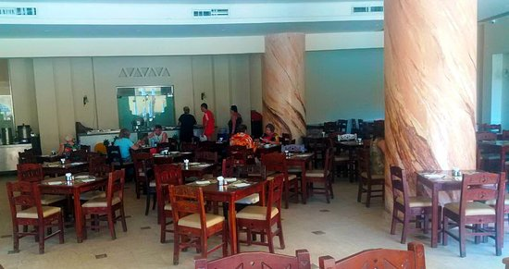  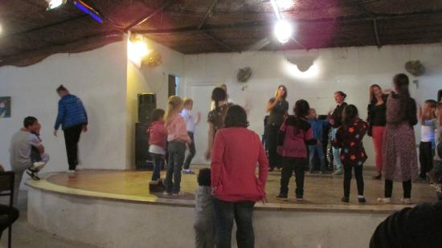

|  |  |  |  |  |
| --- | --- | --- | --- | --- |
| Entertainment, health club gymnastic equipment, mini club, towels, parasols and deckchairs by the pool and on the beach, limited wireless internet connection | | | | |
| HK Services | Mini Bar | Baby Cot | Iron & ironing board | Hair Dryer |
| Daily Cleaning  Towel refreshment &  bed linen refreshment  ✓ |  | upon request   ✓ | upon request   ✓ | upon request   ✓ |



Food & Beverage

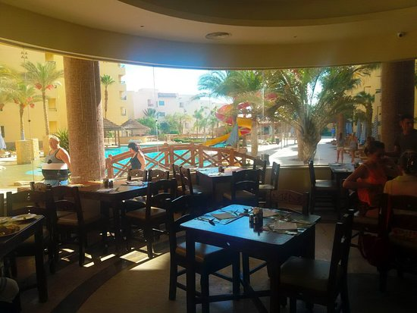

|  |  |  |  |  |  |  |  |  |  |  |  |  |  |  |  |
| --- | --- | --- | --- | --- | --- | --- | --- | --- | --- | --- | --- | --- | --- | --- | --- |
| **Food & Beverage Concept** | | | | | | | | | | | | | | | |
| Main Restaurants | | | | | | | A-La Carte Restaurants | | | | | Bars | | | |
| Snacks Bars | | | | | | | Diet Menu Alternatives | | | | | Ice Crème Service | | | |
| All-Inclusive Concept includes local alcoholic and non-alcoholic brands, served by glass from 10:00 AM – 10.30 PM | | | | | | | | | | | | | | | |
| All-Inclusive Concept does not includes all assigned beverages by menu and served by bottle | | | | | | | | | | | | | | | |
| **Room Service**  Meal  Served at  Time  Buffet / Menu  Breakfast  Main Restaurant  07:00 – 10:00  Open Buffet | | | | | | | | | | | | | | |
| Room Service | | | | | 24 Hrs. | | | | | Menu | | | Extra | |
| **MEALS & SNACKS** | | | | | | | | | | | | | | |
| Meal | | | | Served at | | | | Time | | | Buffet / Menu | | | Seats |
| Breakfast | | | | Main Restaurant | | | | 07:00 – 10:00 | | | Open Buffet | | | 2 floors - 180 seats |
| Lunch | | | | Main Restaurant | | | | 13:00 – 15:00 | | | Open Buffet | | | 2 floors - 180 seats |
| Snacks | | | | Beach Area | | | | 13:00 – 15:00 | | | Fixed Menu | | |  |
| Tea Time | | | | Pool Bar | | | | 16:00 – 17:00 | | | Fixed Menu | | |  |
| Dinner | | | | Main Restaurant | | | | 18:30 – 21:30 | | | Open Buffet | | | 2 floors - 180 seats |
| Late Dinner | | | | Cave Cafe | | | | 22.00 - 23.00 | | | Cold Cuts | | |  |
| Enjoy the International Cuisine of a rich varied buffet at our Main Restaurant  Opening and closing times of the restaurants and bars can be changed according to season and weather conditions | | | | | | | | | | | | | | |
| **BREAKFAST BOX, EARLY BREAKFAST & LATE DINNER** | | | | | | | | | | | | | |
| On the road to explore the historical side of Egypt or enjoy the wonderful undersea world of the Red Sea, then order your Breakfast Box through the Reception one day before your Trip free of charge by max. 20.00 PM  Arrived Late at the Hotel or coming from eventful excursion? We are warmly welcome you at our Late Dinner | | | | | | | | | | | | |
| **ALL INCLUSIVE BARS** | | | | | | | | | | | | | |
| AREA | Service | | | Opening Hours | | | Food & Beverage | | | | | |
| Cave Cafe | Order | | | 24 Hours | | | Local alcohol and soft drinks, coffee, tea | | | | | |
| Beach Bar | Self Service | | | 11:00 - 15:00 | | | Snacks, local alcohol and soft drinks, coffee, tea | | | | | |
| Aqua Park Pool Bar | Self Service | | | 10:00 - sunset | | | Snacks, local alcohol and soft drinks, coffee, tea | | | | | |
| Hard All Inclusive | Tang juice, tea, Nescafe , Beer, mineral water & local alcoholic drinks | | | | | | | | | | | |
| Soft All Inclusive | Tang juice, tea, Nescafe ,mineral water | | | | | | | | | | | |
| Chargeable Items | Fresh Juices - Energy Drinks - Alcoholic Cocktails –Non Alcoholic Drinks – Water Pipe - Espresso - Sisha Cappuccino , Turkish Coffee | | | | | | | | | | | |
| - All drinks to be served in glasses  All Inclusive system start from 10.00 AM till22.30 | | | | | | | | | | | | |



**Services & Facilities**

|  |  |
| --- | --- |
| Service | Fee |
| 24-hrs Concierge Service | Free |
| Coffee Shop | Extra Charge |
| Pool Bar | Extra Charge |
| Take Away Service | Extra Charge |
| Mini Markets | Extra Charge |
| Laundry Service | Extra Charge, Price List available at The rooms |
| Wi-Fi | Free limited around the area, High speed with extra charge |
| Parking | Free outside Hotel, chargeable inside the hotel |
| Kids Club | Free |
| Baby Chair | Free |
| Baby Cot | Free |
| Sport Activities | Free |
| Gym | One hour Free |
| Private Beach | Free |
| Towels | Free |
| Deckchairs | Free |
| Parasols | Free |
| Taxi Service | Extra Charge |
| SPA | Extra Charge |
| Billiard | One hour free per stay |
| Table Tennis | Extra Charge |
| Water & Beach Sport Center | Extra Charge |
| Doctor & Medical Service ( On Call ) | Extra Charge |

# C:\Users\g.m.BLUESEA\AppData\Local\Microsoft\Windows\Temporary Internet Files\Content.Outlook\M8PNO7WW\image6.JPG

|  |  |
| --- | --- |
|  | **Day Time Animation Activities** |

# C:\Users\asuss\Desktop\ZAHABIA\FINAL PHOTOS\RESTAURANT\5.jpgC:\Users\asuss\Desktop\ZAHABIA\FINAL PHOTOS\THEATRE\12.jpg

|  |  |  |  |  |  |  |  |  |  |  |
| --- | --- | --- | --- | --- | --- | --- | --- | --- | --- | --- |
| Time | | Activity | | Location | | | Time | Activity | | Location |
| 10:00 | | Radio Info. | | Pool | | | 15:00 | Radio Info. | | Pool |
| 10:15 | | Stretching | |  | | | 15:05 | Club Dance | | Pool |
| 10:45 | | Boccia | | Beach | | | 15:15 | Darts | | Beach |
| 11:00 | | Beach Volleyball | | Beach | | | 15:30 | Boccia | | Beach |
| 11:15 | | Belly Dance | | Beach | | | 15:30 | Volley Ball | | Beach |
| 11:45 | | Aqua Aerobic | | Pool | | | 15:30 | Water Polo | | Pool |
| 12:15 | | Funny Games | | Beach | | | 16:00 | Dance Lesson | | pool |
| 12:30 | | Club Dance | | Beach | | | Enjoy With Our Animation Team | | | |
| **Animation Show - Evening Program** | | | | | | | | | | |
| Day | Time | | Location | | | Show | | | | |
| Monday | 21:30 | | Theatre | | | Surprise Show | | | | |
| Tuesday | Tanoura Dance Show | | | | |
| Wednesday | Beach Party | | | | |
| Thursday | Acrobat Show | | | | |
| Friday |  | |  | | | Fakir Show | | | | |
| Saturday | Music Quiz Show | | | | |
| Sunday | Belly Dance Show | | | | |
| Entertainment | | | Aerobics | | | Live Music | | | DJ | |
| **Pools & Beach** | | | | | | | | | | |
| Pools | | | Water | | Min-Max Depth | | | | Size | |
| Tenth Pool | | | Fresh water | | 105 CM / 195 CM | | | | 175 m2 | |
| Children Pool | | | Fresh water | | 50 CM | | | | 50 m2 | |
| Aqua Pool | | | Fresh water | | 60 CM - 195 CM | | | | 825 M2 | |
| Kids Pool | | | Fresh water | | 60 CM | | | | 23 M2 | |
| Sandy beach, swimming shows recommended, sun beds, parasols and beach towels included, water sport activities are available. | | | | | | | | | | |

|  |  |  |  |  |  |  |  |  |
| --- | --- | --- | --- | --- | --- | --- | --- | --- |
| **Included in All-Inclusive Concept** | | | | | | | | |
| Kids Pools | Kids Playgrounds | | | Kids Club | | Darts | | Dancing Show |
| Aqua Park | Animation Activities | | | Water Aerobics | | Fitness | | Boccia |
| Billiard : 1 hrs free of charge per stay per room from 10:00 AM – 19:00 PM | | | | | | | | |
| **Not Included in All Inclusive Concept** | | | | | | | | |
| Water Sport Activities | | Parasailing | Boat Excursions | | Billiard | | High Speed WiFi | |
| Turkish Hamam | | Sauna | Steam Bath | | Massage | | Jacuzzi | |

# C:\Users\g.m.BLUESEA\AppData\Local\Microsoft\Windows\Temporary Internet Files\Content.Outlook\M8PNO7WW\image6.JPG

|  |
| --- |
| **For Children** |

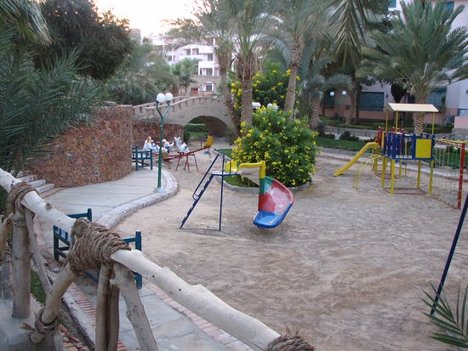 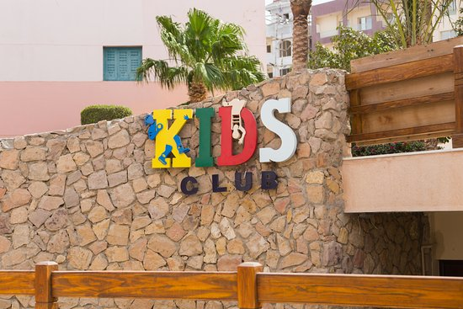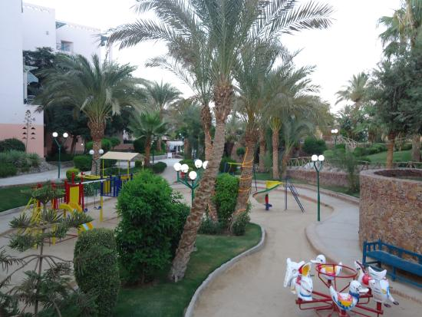

|  |  |  |  |
| --- | --- | --- | --- |
| Facilities | Opening hours | Characteristics | Free |
| Mini club | 11.00 – 12.30  15.00 – 16.45 | Age of usage: 5-10 years old, |
| Mini Disco | 20:30 | Theatre Area, Kids Animation |
| Kids pool | 09.00 - Sunset | Kids Pool (not heated) and must be attended by parents |
| Kids playground | Open all day | kids must be attended by parents |
| Baby Cot | Upon check-in | Upon request provided to guest rooms |
| Baby Chair | During all meals time | Available at the main restaurant |
| Buffet | During the meal time | Varied Buffet for our youngest guests at the Main Restaurant |

|  |  |  |  |  |
| --- | --- | --- | --- | --- |
|  |  |  | **SPA & Wellness** |  |



|  |  |  |  |  |  |  |  |  |  |
| --- | --- | --- | --- | --- | --- | --- | --- | --- | --- |
|  |  |  | **We invites to plunge into the world of beauty, relaxation and elite care** | | | | | |  |
| Gym | Sauna | | | Jacuzzi | Scrubs & Body Wraps | Relax Pool | Steam Bath | Massage | Therapies |

|  |  |  |  |  |
| --- | --- | --- | --- | --- |
|  |  |  | **Security** |  |

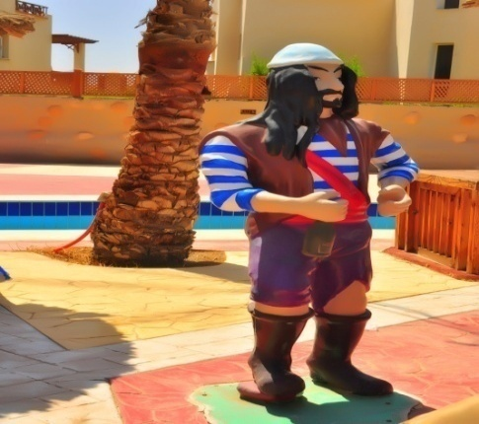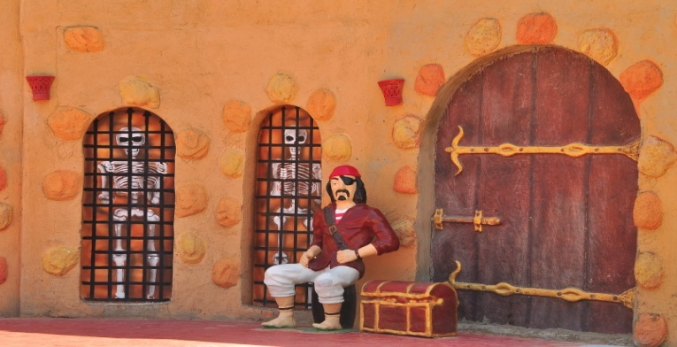

|  |  |  |  |
| --- | --- | --- | --- |
| Balcony fence apertures are 110 cm | Fire Exits | Signboards around the pool | Warning signs |



|  |  |  |  |  |
| --- | --- | --- | --- | --- |
|  |  |  | **Useful Information** |  |

*All swimming pools and beach activities are subject to weather conditions.

*The hotel holds no responsibility for any injury or accidents with the use of the swimming pool and beach

*Don’t swim under the influence of alcohol

*Children must be accompanied by an adult.

*Toddlers with diapers are not allowed in the pool or the sea.

*No flotation toys are allowed in the pool except water rings

*Soccer or ball games, bicycling, skating, running, pushing, dunking and any other sort of disturbances are not allowed in or around the swimming pool area and beach.

*The hotel cannot be held responsible for any loss or damage of personal belongings or valuables.

*Glass containers are not allowed in or around the swimming pool area and beach.

*Alcoholic drinks are restricted to ages under 18.

*All imported beverages have been legally brought into the country.

*Schedules and venues for outdoor events are subject to weather conditions.

*For your safety, Please follow the elevator Rolls

* Follow the Aqua Park rules & make this adventure Safe for You & Your children

* For your safety, footwear is advised for stepping into the open sea, forbidden to touch the corals or step on them or take shells or coral and feed fish

*Zahabia Hotel & Beach Resorts reserves the right to make changes without prior announcement.

*The hotel management is fully authorized to make amendments and/or cancellations regarding any aspect of the services offered. If and when such changes are made, the new-irrelevant information in the catalogue will be construed as simultaneously reflecting the changes made.

* TOK-TOK: Daily From/to the beach from 9:00 to 17:00 chargeable

From the entrance to the beach or Back, one way LE 05.00

From the entrance to the Marina or Back, one way LE 10.00

* Parking Area outside hotel is free of charge, Parking inside the hotel per day LE 50.00, Weekly LE 250.00

* Car parking inside the beach area, LE 20.00 per day

* Return your bracelet back to the reception on your departure day by max.12.00h, $10.00 will charged for the lost bracelet.

* losing towel or towel card will be charged $10.00 per card.

* We reserve the right to charge for lost or broken room card or key card $10.00.

*Doctor is available on call 24hrs. Charges excluding the medicines depend on your medical insurance; take your Passport & insurance with you.

\****DO NOT PAY CASH IN ANY OUTLETS!*** All checks must be signed to your room account & to be paid at the Reception

***Zahabia Hotel & Beach Resort***

***Hurghada Egypt***

Web:[www.zahabiaresort.com](http://www.zahabiaresort.com)

Facebook: Zahabia Beach Resort

Mail:zahabia_resort@yahoo.com



