COVID -19Grand Halomy Resort.

COVID -19
Disinfections Procedure

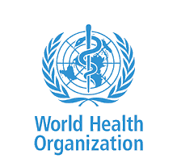
Guidelines of local health authorities, WHO and we act according to our procedures to prevent the spread of infection

General Disinfections

During Covid -19 Outbreak Hotel start General Clean & Disinfections Procedure matching with All Instructions of WHO .
apply Sanitization at The major areas of the hotel ,

We disinfect All Building entrances, public areas,; rooms, back house areas, vehicles and high touch areas ; using 1000 to 4000 ppm sodium hypochlorite,

Staff Members

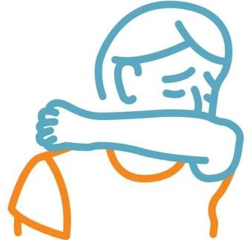
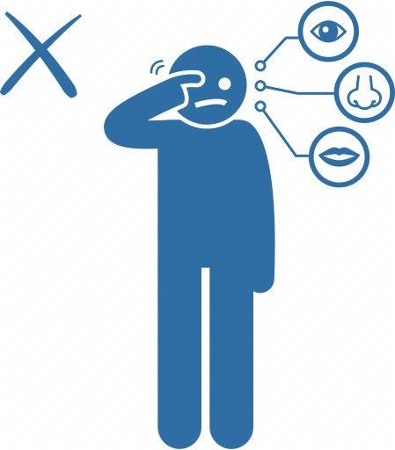
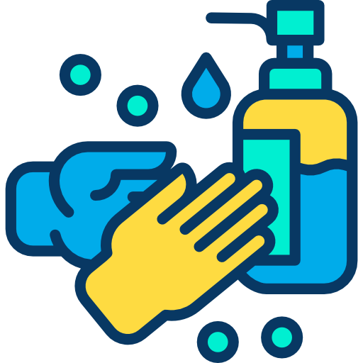
Provide our Staff all Information’s and Materials about COVID 19 Disinfections & they trained by the following steps :-
- Wash the hands frequently with soap and water and dry them well.

- - Avoid touching their eyes, nose and mouth.

- - Avoid contact with others (touching, kissing, hugging and other intimate contact)

- - Cover coughs and sneezes with clean tissues

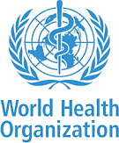

Entrance / Reception Lobby

Reception and concierge they play important role in information and communication Reception desk staff know sufficiently about COVID-19 so that they can safely carry out their assigned tasks.
Official, up-to-date information is available about travel to and from countries or areas where COVID-19 is spreading.
All front office staff wears surgical masks during their duties. Concierge team offer hand sanitizer for the guests upon arrival and before entering the hotel.

Hotel Rooms

Housekeeping and cleaning staff should inform the management or the reception desk of any possibly sick guests in their rooms. Cleaning plan is followed for guest rooms by focusing on high touch areas which are used by every one in room as well as housekeeping and else visiting the room So we give them a good wipe down on daily basis

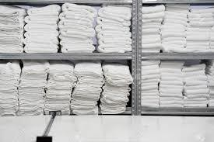
- Chlorine at 1000ppm is used for disinfection procedure. We use specific clothes, scourers (sponges) and bags. We increase the frequency of cleaning and disinfecting. We supply housekeeping team by sufficient disinfectants; PPE and others supplies.

- For soft furnishings (sofas, mattresses, etc.), other cleaning procedures may be used: steam cleaning (vaporizer) Linen management linens, and clothes should be put in special, marked laundry bags and handled carefully. Clean and disinfect hampers or other carts for transporting of laundry. Instructions is given for washing them in hot cycles (70ºCor more)with the usual detergents.

Swimming Pool

- We maintain the conc. of disinfectant in water for consumption and in
pool or spas within the limits recommended.

- General good practices, sufficient dressing rooms, shower rooms , toilet facilities and lockers for the guests are available.

- Adequate hand washing facilities including liquid soap, paper towels, hand dryer and Hand gel are available. Regular disinfection of high touch areas such as door handles, card terminals and elevator buttons with anti-bacterially Liquids.

- We offer disinfectant dispensers in public areas to our guests

Dining Room
- All crockery and utensils used at the buffet counters including tongs, spoons
and under liner are changed and sanitized every 20 minutes.

- Dining tables and chairs are sanitized with designated disinfectant before serving new guests, so our guests can find a pleasant and safe dining experience at all restaurants. Table arrangement has been adjusted to 1.5m distance from each other. Maximum off our people are allowed portable

- Our staff perform personal hygiene focusing on frequent regular hand washing, cough hygiene; strictly .

- Service staff are ensuring (and asking the guests) to use sanitizer gel at restaurant entrance. Suppliers of goods and services Contractors follow safe systems of work to prevent the spread of COVID-19

Grand Halomy Resort.

COVID -19
Disinfections Procedure

