**Dear Guest,**

**We are extremely pleased for having you here in Casa Mare Resort to celebrate the New Year with us.**

**As we rapidly approach 2024, let me seize this opportunity to draw your attention to the exciting New Year Eve Program that we have prepared for you.**

**All the Team of Casa Mare Resort wishing you “Joy, Peace, Health, Wealth & Happiness” for the New Year 2024.**

**General Manager**

**&**

**Management Team**

***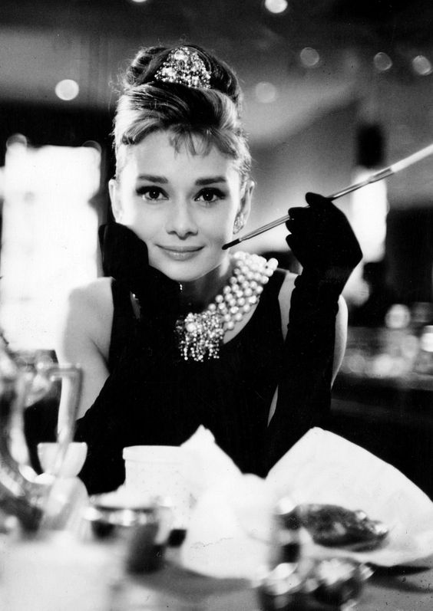*New Year Entertainment Program**

***31st of December 2023***

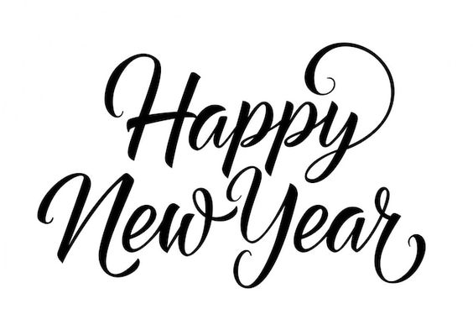

|  |  |
| --- | --- |
| **Time** | **Event** |
| **18:00 Till 19:00** | **Guest Entrance & Buffet Opening** |
| **19:30 Till 20:15** | **Live Band** |
| **20:15 Till 21:00** | **Folklore Show -Belly Dancer -Tanoura** |
| **21:00 Till 21:30** | **G.M Speech** |
| **21:30 Till 22:00** | **Colombian Show** |
| **22:00 Till 22:45** | **Casa Mare Dance Show** |
| **22:45 Till 23:58** | **Live Band & Countdown** |
| **24:05**  **Till Unlimited** | **Disco with DJ** |