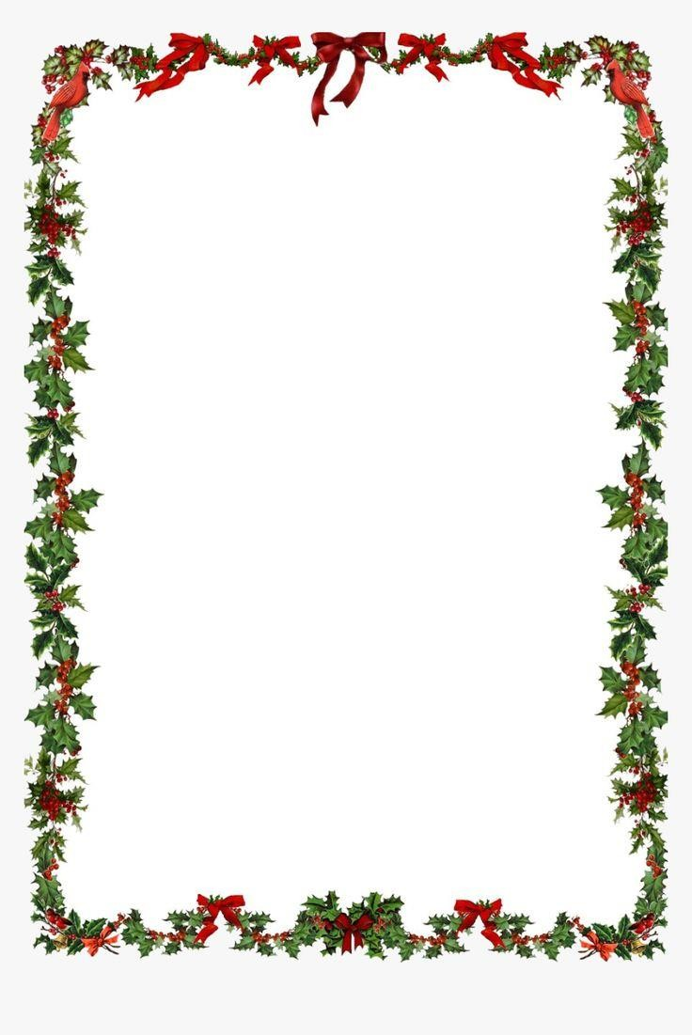

New year program 2025

New year program 2023

New year buffet

**Hot station**

Soup

**1. Seafood Bisque soup**

**2. Beef Consommé**

chafing dish

**1. Basmati rice with nuts**

**2. Mixed rice of three different colors with nuts**

**3. Sautéed vegetables**

**4. Lasagna in three colors**

**5. Fish roll and salmon**

**6. Potatoes with herbs& butter**

**7. Beef Medallion**

**8. Cauliflower, cumin and nuts**

|  |  |  |  |  |  |  |  |
| --- | --- | --- | --- | --- | --- | --- | --- |
| **Time** | | **Location** | | |  | **Show** | **Kids** |
| **10:30 to 11:30 AM** | | **Beach area** | | | **Color festival** | | **Face painting** |
| **15:30 to 16:30 pm** | |  | **Beach area** | | **Olympic games** | | **Ice cream**  **&magic show** |
|  |  |  |
| **16:30 to 17:00 pm** | | **Beach area** | | | **Club dance** | | **Mini disco** |
| **18:00 to 18:30 pm** | | **Salsa bar** | | | **Cocktail reception with mirage management** | | |
|  |  |  | |  | **Entrance to the Restaurant** | | |
| **18:30 to 19:00 pm** | | **Main big Restaurant** | | |
| **19:00 pm** | | **Main big Restaurant** | | | **Start the Buffet time** | | |
| **19:15 to 20:15 pm** | | **Main big Restaurant** | | | Live band | | |
| **20:15 to 20:45 pm** | | **Main big Restaurant** | | | Oriental Show | | |
| **20:45 to 21:15 pm** | | **Main big Restaurant** | | | Tanoura Show | | |
| **21:15 to 22 :15 pm** | | **Main big Restaurant** | | | Animation Dance Show | | |
| **22:15 to 22:45 pm** | | **Main big Restaurant** | | | **Folklore Show** | | |
| **22:45 to 23:00 pm** | | **Main big Restaurant** | | | Fire Show | | |
| **23:00 to 23:59 pm** | | **Main big Restaurant** | | | **Live band saxophone** | | |
| **00 to 00:01 AM** | | **Main big Restaurant** | | | **Countdown** | | |
| **00:01 to 1:30 am** | | **Main big Restaurant** | | | **Dance floor** | | |
| **1:30 am** | | **Main big Restaurant** | | | **Slow music** | | |

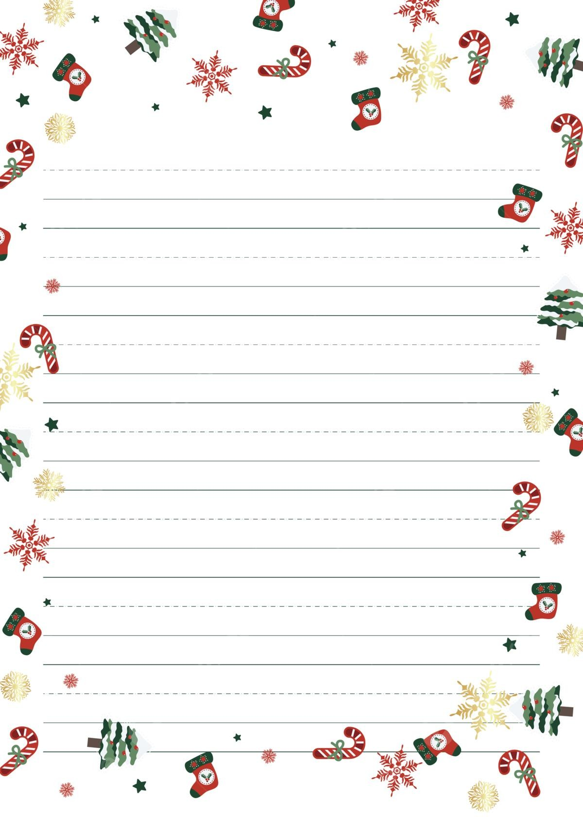

New Year menu

Mirrors

Roast beef - Sushi - Cheese - Fish roll - Stuffed seafood artichokes –

Hand pasta - Duck - Fish fillet - Stuffed peppers

- Mini burger - Stuffed eggs - Smoked salmon

Salad

Seafood salad with dill

Chicken salad with sweet sour

Mushroom salad - Noodle salad

Caesar salad - Carmen's salad

Waldorf salad - Fish curry salad

crab stick salad - Fresh vegetables

Tahini salad - Tabbouleh - Monk salad

Baba Ghanoush / Oils &Sauces corner

Selection of sauce & dressing

(Roquefort, balsamic vinegar, soya, yogurt, Italian, French, basil)

CARVEN

Birds’ carnival …. Whole fish……mutton

**Main Dishes**

**Beef Wellington - Trebianco - Shrimp Grill**

**Hawk Black Mussels - Mix grill - Pasta station**

**Mixed rice - Seafood rice - Sautéed vegetables**

**- Beef fillet - Lasagna - Couscous –**

**Calamari casserole - Pommes cheese - Eggplant poppet**

**Dessert & SWEETS**

**(Collection of Oriental and French pastry)**

**FRESH FRUIT CORNER**

**Happy New Year**

