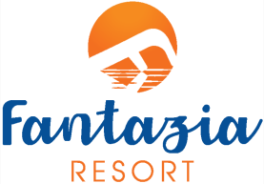
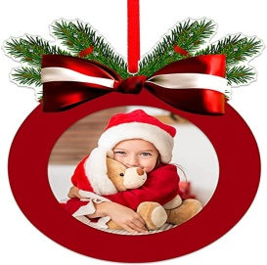
Christmas Program
24/12/2023
- 19:00 - Aperitif Cocktail & Snacks in Aperitif Bar.
- 19:30 - Welcome in the Main Restaurant.
- 20:00 - Open Buffet &Life Singer during the Dinner.
- 22:00 -Start mini disco in the Roman Theatre.
- 22:30 -Starting Animation Show in the Roman Theatre.
- 23:20 - Panettone in Front of Fantazia Disco.
- 23:30 - Open Disco.
25/12/2023
- 11:00– Santa Claus on the Beach with Camel.
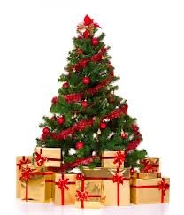
Merry Christmas

