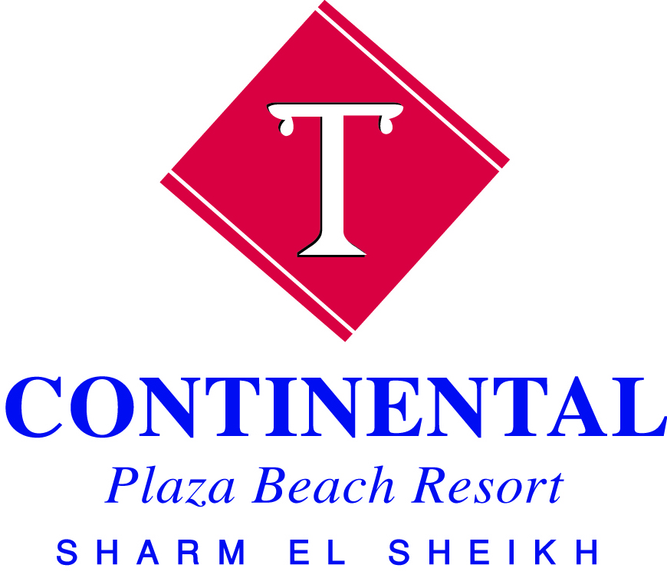
ENGLISH
Enjoy our All Inclusive system the whole stay.

All soft drinks and local alcoholic beverages are served by glasses (wine is served during
Meals only in main restaurant).

All Inclusive Concept Room service, minibar, imported beverages, Turkish coffee, water bottles, fresh juices,
Drinks in bottles or cans are available (with extra charge).
*Please be informed that it is necessary to wear the bracelet all the time during your stay.
According to our hotel policy it’s not allowed to take any food from the restaurants due to
Hygienic reasons.

Panorama & La Duna Restaurant(Buffet style) Breakfast: 07:00 AM - 10:00 AM
Lunch: 13:00 PM - 03:00 PM
Dinner: 06:30 PM - 09:00 PM

*Meals are served at both Panorama & La Duna Restaurant
Snacks
Fayrouz & Beach Bar: 10:00AM – 12:00 PM
04:00 PM - 05:30 PM

Late dinner in Panorama Restaurant: 11:00 PM - Midnight

A la carte Restaurants please reserve in advance with Reception from 09:00 AM till 12:00 AM.
Italian: 07.00 PM – 09:00 PM
B.B.Q(Extra Charge): 07.00 PM – 09:00 PM
Sea Food (Extra Charge): 07.00 PM – 09:00 PM

*For a La Carte restaurant enjoy a free visit once per stay for each restaurant except the sea food one,

Bars Lounge Bar: 10:00 AM – 11.00pm
Belveder Bar: 10:00 AM – 11.00pm
Cocktail Bar: 10:00 AM – 05.00pm
All Season Bar: 10:00 AM – 05.00pm
Fayrouz Bar: 10:00 AM – 05.00pm
Beach bar: 10:00 AM –05.00pm
Aqua Bar: 10:00 AM –04.00pm * Alcoholic drinks will not be served to children or guests less than 18 years old.
*Turkish coffee, and fresh juices with extra charge.
Bank For money exchange and cash with draw you will find ATM machine beside reception.
Breakfast Box Please contact Reception to order your breakfast box or wake up call.
Kindly be informed that the latest time to order a breakfast box is one day in
Advance till 08:00 PM.
Check In & check Out Check In time at 02:00 PM and check out time before 12:00 PM.
Please leave your luggage outside your room and our Bellman will bring it to the
Reception.
Please return your Key card and Towels cards.
If you need late Check Out, please check availability and prices with Reception.
Diving Center (with extra charge) for information please visit diving center on the beach.
Pharmacy and Doctor A Pharmacy is situated in the hotel Shopping area. A Doctor on call 24 hours.
In case of emergency, please contact the Reception, dial 0.
Dress Code Swimming suits are not recommended at the Lobby area, as well as in the
Restaurants during your breakfast, lunch and dinner.
Entertainment 7 nights per week. Different Shows at 9:00 PM at the Amphitheatre or at the Discotheque.
Health Club Free Gym usage. Turkish bath, spa, Massage, Sauna, Jacuzzi, Beauty salon with extra
Charge for further information contact Spa Center Extension No 130.
Kids Club Open daily from10.00 AM-12.00 PM &15:00 till 17:00.
Mini disco daily from 08.30 PM at the Amphitheatre or Discotheque.
Laundry (with extra charge) you will find a price list and laundry bag in the wardrobe.
Payment at the reception before Check Out.
Mini Bar (with extra charge) if you need to fill up your Mini Bar, please contact the Reception Desk (dial 0).
Room Cleaning service Time for the room cleaning – daily from 09:00 AM till 05.00 PM.
If you prefer a special time for cleaning, please use the door sign or call Reception.
Safe box Safe box is available in your room, free of charge, using instruction near safe box.
Keep your safe door open before your Check Out.
Please always keep your money and valuable things in the safe box.
*The Management of Continental Plaza Resort takes no responsibilities
For Money or valuable things in the rooms kept out of the safe box.
Guest Relation For any information, special requirements, please contact our Guest Relation (Dial ).
Sports Our sport activities on the pool and the beach are free of charge.
i.e.: Water polo, bocha, beach tennis, volleyball, darts, giant chess, and aerobics.
The Hotel Cannot be held responsible for any sport accidents
Swimming Pools & Aqua Park 5 Swimming Pools from 8:00 Am till sunset time for each adults and kids
Aqua Park from10:00 till 12:00 and 14:00 till 16:00.
Sun beds are not to be reserved before 08:00AM or during the operation time.
For safety reasons, proper swim suits are required.
Please check carefully the instruction signs at the pool areas. For more information,
Please, ask our Recreation Staff.
Towel Card & Towels Towel Card will be handed out from Reception upon Check in
Towels are available at the Towel Center.
From 08:00 AM till 05:00 PM (only 1 towel per day).

Shuttle Bus Daily tour to Neaama Bay , two times during the day against 2$
For reservation , please contact the reception

Lost Key or towel Card In Case of losing or breaking your room key or towel Card will be charged to your bill with
10USD.
Conference Room Capacity of 150 Pax as a theater Shape located at the main building
WI-FI WI-FI internet, cards are available at the Reception With no extra charge.
Shopping Centre in our shopping Centre are different souvenir shops, pharmacy and a mini market.

Limousine Service A Limousine desk is available in the lobby area.
IMPORTANT NOTES:
- It is not allowed to walk or stand on the corals, please do not break or collect corals & shells.
- Inviting guests from outside is only allowed at the Reception area.
- Smoking is not allowed indoors area.
- It is not allowed to smoke Shisha in your room or on the room terrace.
- In case of lost your bracelet will be charged to your bill.

