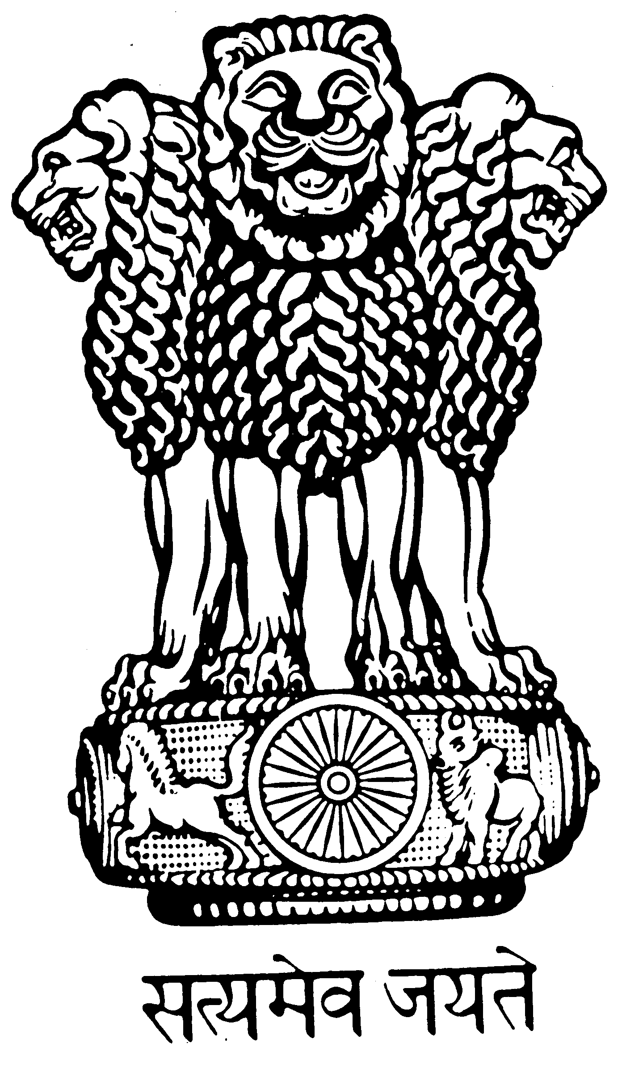
Embassy of India
4, Ulitsa Vorontsovo Polye, Moscow - 115127
Tel : +7-495-9174835, Fax: +7-495-9162343, Email: fscons@indianembassy.ru
Additional Form for Foreigners
(Also to be filled by Russians who acquired citizenship by naturalization or have dual citizenship)

From: Indembassy Moscow
To : Indembassy/Hicomind/Congendia ________________

Clearance in respect of the following applicant is requested who has applied for Indian visa:
1 | Full name of the applicant |  | IVANOV IVAN MALE– фамилия и имя туриста, пол туриста
2 | Name of father/husband |  | BORIS – указать имя папы или супруга
3 | Date of birth |  | 11.11.1984 – указать дату рождения туриста
4 | Nationality | Present | RUSSIA  Гражданство в настоящее время
4 | Nationality | Dual | Заполняется если турист имеет двойное гражданство
4 | Nationality | Previous | GERMANY  Гражданство при рождении
5 | Passport No |  | Серия и номер загранпаспорта  65N1111111
6 | Date of expiry |  | Дата окончания загранпаспорта  31.12.2020
7 | Type & duration of visa applied for |  | Tourism/1month/3 month или 6 month в зависимости от срока действия запрашиваемой визы  SINGLE ENTRY/ DOUBLE ENTRY  – в зависимости от кратности запрашиваемой визы

For official use only

If no reply is received in 3 working days, it will be presumed that you have no objection to issue of visa.
Urgent reply is requested. Visa will be issued on clearance only.

Yours Sincerely,

Assistant Consular Officer

