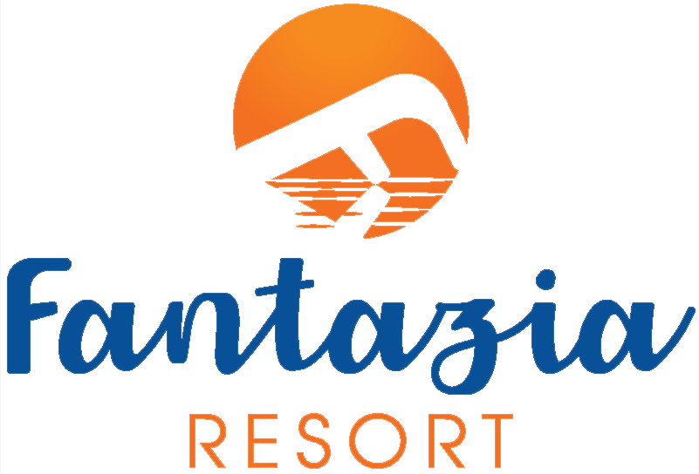

New Year Program
31/12/2023
16:00-Foam Party on the Beach.
20:00 - Aperitif Cocktail inGazebo Bar.
20:30 - Welcome in theMain Restaurant.
21:00 - Open Buffet+ Life Singer during the dinner.
22:45 - Oriental oboe with Fantazia surprise.
23:15 - Oriental Show in the Reception.
00:00 -Animation Show
in the Reception.
01:00–Countdown&Balloons.
01:10 - Open dance with international music until finish the New Year party.
02:00 –Countdown with international music.

All This Time is Fantazia Time

